|  |  |  |
| --- | --- | --- |
|  | |  |
|  |  | |
|  | Introduction to QGIS | |
|  | Programme  Report | |
|  |  | |
|  |  | |
|  |  | |

|  |  |  |
| --- | --- | --- |
|  |  | BRITISH GEOLOGICAL SURVEY  Learning and development Programme  REPORT |
|  |  |
| The National Grid and other Ordnance Survey data © Crown Copyright and database rights 2017. Ordnance Survey Licence No. 100021290 EUL.  *Keywords*  .  *Front cover*  Image of QGIS exercise 8. Geology around Nottingham.  *Bibliographical reference*  2017.  . *British Geological Survey Report*, . pp.  Copyright in materials derived from the British Geological Survey’s work is owned by the Natural Environment Research Council (NERC) and/or the authority that commissioned the work. You may not copy or adapt this publication without first obtaining permission. Contact the BGS Intellectual Property Rights Section, British Geological Survey, Keyworth,  e-mail ipr@bgs.ac.uk. You may quote extracts of a reasonable length without prior permission, provided a full acknowledgement is given of the source of the extract.  Maps and diagrams in this book use topography based on Ordnance Survey mapping. |  |
|  |
| © *NERC 2017. All rights reserved* | Keyworth, Nottingham British Geological Survey 2017 |

**BRITISH GEOLOGICAL SURVEY**

The full range of our publications is available from BGS shops at Nottingham, Edinburgh, London and Cardiff (Welsh publications only) see contact details below or shop online at www.geologyshop.com

The London Information Office also maintains a reference collection of BGS publications, including maps, for consultation.

We publish an annual catalogue of our maps and other publications; this catalogue is available online or from any of the BGS shops.

*The British Geological Survey carries out the geological survey of Great Britain and Northern Ireland (the latter as an agency service for the government of Northern Ireland), and of the surrounding continental shelf, as well as basic research projects. It also undertakes programmes of technical aid in geology in developing countries.*

*The British Geological Survey is a component body of the Natural Environment Research Council.*

*British Geological Survey offices*

**BGS Central Enquiries Desk**

Tel 0115 936 3143 Fax 0115 936 3276

email enquiries@bgs.ac.uk

**Environmental Science Centre, Keyworth, Nottingham NG12 5GG**

Tel 0115 936 3241 Fax 0115 936 3488  
email sales@bgs.ac.uk

**The Lyell Centre, Research Avenue South, Edinburgh  
EH14 4AP**

Tel 0131 667 1000 Fax 0131 668 2683  
email scotsales@bgs.ac.uk

**Natural History Museum, Cromwell Road, London SW7 5BD**

Tel 020 7589 4090 Fax 020 7584 8270  
Tel 020 7942 5344/45 email bgslondon@bgs.ac.uk

**Cardiff University, Main Building, Park Place, Cardiff  
CF10 3AT**

Tel 029 2167 4280 Fax 029 2052 1963

**Maclean Building, Crowmarsh Gifford, Wallingford   
OX10 8BB**

Tel 01491 838800 Fax 01491 692345

**Geological Survey of Northern Ireland, Department of Enterprise, Trade & Investment, Dundonald House, Upper Newtownards Road, Ballymiscaw, Belfast, BT4 3SB**

Tel 028 9038 8462 Fax 028 9038 8461

www.bgs.ac.uk/gsni/

*Parent Body*

**Natural Environment Research Council, Polaris House,  
North Star Avenue, Swindon SN2 1EU**

Tel 01793 411500 Fax 01793 411501  
www.nerc.ac.uk

Website www.bgs.ac.uk   
Shop online at  [www.geologyshop.com](http://www.geologyshop.com)

# Foreword

This is BGS internal course manual for the Introduction to QGIS course.

It outlines the basic tools that come with QGIS to ensure a smooth transition to ArcGIS users.

# Contents

Foreword i

Contents ii

Summary iv

1 Introduction 1

1.1 QGIS in BGS 1

2 Installation 2

2.1 Help 2

3 The QGIS map interface 4

3.1 Exercise: open QGIS 4

4 Toolbars 5

5 Loading Data 7

5.1 Vector data: 7

5.2 CSV text files: 7

5.3 Raster data: 7

5.4 Adding Background data: 8

5.5 Exercise: loading data 8

6 Plugins 10

6.1 Loading background maps 10

6.2 Exercise: Background Map 11

7 Coordinates/Projection 12

7.1 On the Fly CRS transformation 12

7.2 How to save data to another CRS 12

7.3 Exercise: Projection 13

8 Styling Data 14

8.1 Styling Raster Layers 14

8.2 Styling Vector Layers 17

8.3 Saving Layer Styles 17

8.4 Exercise: Raster Styling 19

8.5 Exercise: Vector Styling 19

8.6 Exercise: Saving Styles 19

9 Spatial Joins 20

9.1 Exercise: Spatial Join 21

10 Selecting Data 22

10.1 Selecting with the mouse 22

10.2 Selecting with expressions 22

10.3 Selecting with filters 23

10.4 Atribute table tools 25

10.5 Exercise: Selecting Data 25

11 Data Creation and Editing 26

11.1 Creating a New Vector Layer 26

11.2 Adding/Digitizing data 26

11.3 New scratch layer 26

11.4 Exercise: digitising 26

12 Print Composer 27

12.1 Save as Image 27

12.2 Print Composer 27

12.3 Exercise: print map-layout 28

13 Plugins 30

13.1 Useful QGIS Plugins 31

14 Connecting to databases 35

Appendix 1 Core Plugins 38

References 39

# Summary

This course has been written with the intension of allowing a smooth quick transition between ArcGIS users and QGIS. It is not intended for novice GIS user.

It explains the basics of adding layers, querying them, styling them and printing them. It also includes how to get help and some useful plugins.

# Introduction

QGIS is a [geographic information system](https://en.wikipedia.org/wiki/Geographic_information_system) (GIS) software application, allowing users to analyse and edit spatial information, in addition to composing and exporting graphical maps. QGIS supports both [raster](https://en.wikipedia.org/wiki/Raster_graphics) and [vector](https://en.wikipedia.org/wiki/Vector_graphics) layers; vector data is stored as either point, line, or [polygon](https://en.wikipedia.org/wiki/Polygon_(computer_graphics)) features. Multiple formats of raster images are supported and the software can [georeference](https://en.wikipedia.org/wiki/Georeferencing) images.

QGIS supports [shapefiles](https://en.wikipedia.org/wiki/Shapefile), [coverages](https://en.wikipedia.org/wiki/Coverage_data), personal geodatabases, [dxf](https://en.wikipedia.org/wiki/Dxf), [MapInfo](https://en.wikipedia.org/wiki/MapInfo_Professional), [PostGIS](https://en.wikipedia.org/wiki/PostGIS), and other formats. Web services, including [Web Map Service](https://en.wikipedia.org/wiki/Web_Map_Service) and [Web Feature Service](https://en.wikipedia.org/wiki/Web_Feature_Service), are also supported and allow the use of data from external sources.

QGIS integrates with other open-source GIS packages, including [PostGIS](https://en.wikipedia.org/wiki/PostGIS), [GRASS GIS](https://en.wikipedia.org/wiki/GRASS_GIS), and [MapServer](https://en.wikipedia.org/wiki/MapServer). [Plugins](https://en.wikipedia.org/wiki/Plug-in_(computing)) written in [Python](https://en.wikipedia.org/wiki/Python_(programming)) or [C++](https://en.wikipedia.org/wiki/C%2B%2B) extend QGIS's capabilities. Plugins can geocode using the [Google Geocoding API](https://developers.google.com/maps/documentation/geocoding/), perform geoprocessing functions, which are similar to the standard tools found in [ArcGIS](https://en.wikipedia.org/wiki/ArcGIS), and interface with [PostgreSQL](https://en.wikipedia.org/wiki/PostgreSQL)/[PostGIS](https://en.wikipedia.org/wiki/PostGIS), [SpatiaLite](https://en.wikipedia.org/wiki/SpatiaLite) and [MySQL](https://en.wikipedia.org/wiki/MySQL) databases.

QGIS is a [free software](https://en.wikipedia.org/wiki/Free_software) application under the [GNU](https://en.wikipedia.org/wiki/GNU_GPL) General Public License. QGIS can be freely modified to perform different or more specialized tasks. Two examples are the QGIS Browser and QGIS Server applications, which use the same code for data access and rendering, but present different front-end interfaces

Gary Sherman began development of Quantum GIS in early 2002, and it became an incubator project of the [Open Source Geospatial Foundation](https://en.wikipedia.org/wiki/Open_Source_Geospatial_Foundation) in 2007. Version 1.0 was released in January 2009. The latest “long-term support” release is 2.18 “Las Palmas” 21 October 2016, though the most recent version, 3.0 “Girona” was released on 23 February 2018.

As of 2017, QGIS is available for multiple operating systems including [Mac OS X](https://en.wikipedia.org/wiki/Mac_OS_X), [Linux](https://en.wikipedia.org/wiki/Linux), [Unix](https://en.wikipedia.org/wiki/Unix), and [Microsoft Windows](https://en.wikipedia.org/wiki/Microsoft_Windows). A mobile version of QGIS was under development for [Android](https://en.wikipedia.org/wiki/Android_(operating_system)) as of 2014.

QGIS is maintained by volunteer developers who regularly release updates and bug fixes. As of 2012[[update]](https://en.wikipedia.org/w/index.php?title=QGIS&action=edit), developers have translated QGIS into 48 languages and the application is used internationally in academic and professional environments. Several companies offer support and feature development services.

## QGIS in BGS

As information becomes increasingly spatially aware, there is no shortage of tools able to fulfil some or all commonly used GIS functions. QGIS has the advantage of being free software that can be used for overseas work or for commissioned projects where the customer does not have the finances for a licensed product. BGS should be prepared for when the demand on using free software grows. There is also extensive help and documentation available on the internet.

Nevertheless, it is worth mentioning that ArcGIS is the corporate software agreed to be used within NERC. Any projects within BGS should always be done using ArcMap.

“…Corporate software are agreed as ‘software required by the majority of BGS staff.’ Staff may not use alternative products that provide similar functionality to any corporate software unless business imperative requires this, in which case a business case must be presented to LM before purchasing…”

# Installation

QGIS is freely available on Windows, Linux, MacOS X, BSD, and Android.

QGIS can be downloaded from the official website, <http://www.qgis.org>. Users can choose to download the latest version (which is the most feature rich but may be less stable) or the Long Term Release, which is a slightly older version that has been specifically configured to be stable.

For the purpose of this course, we will install version 2.18.

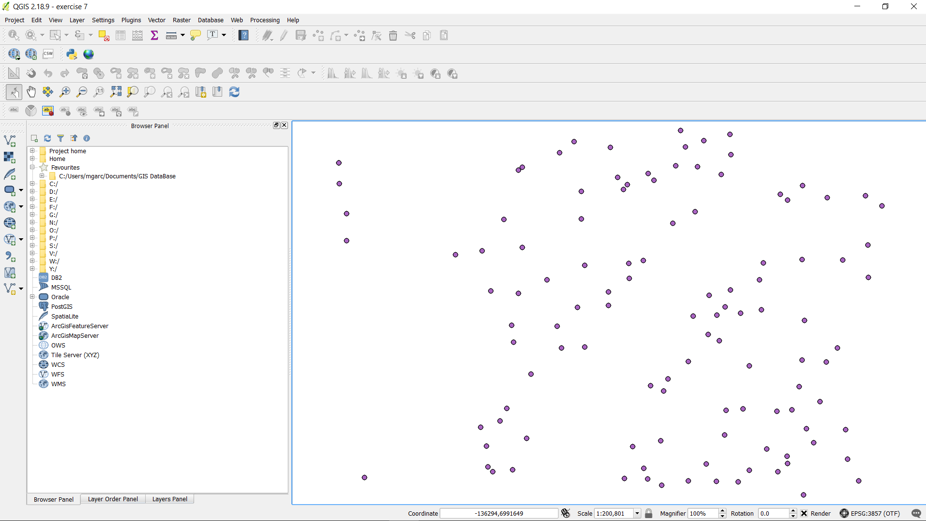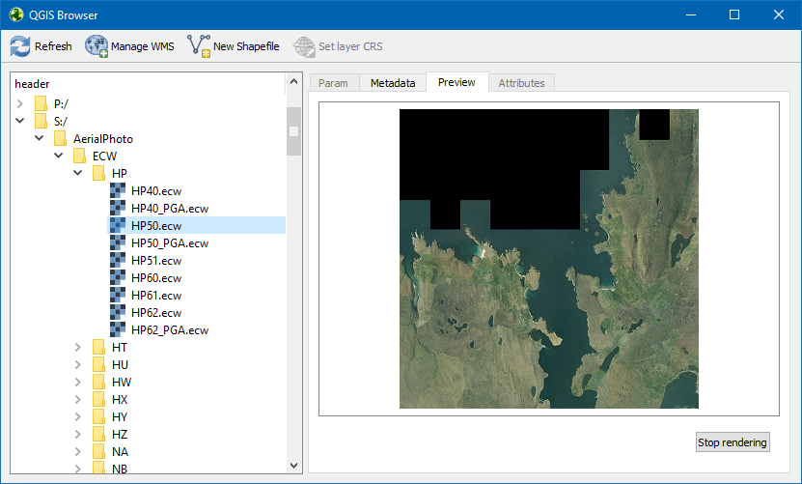

## Help

There is a lot of help in the internet about the use of this software. Detailed documentation can be found at: <https://docs.qgis.org/2.18/en/docs/training_manual/index.html>

You can also join our QGIS mattermost group (which can be found at <https://kwvmxchat.ad.nerc.ac.uk/bgs/channels/qgis>) to post questions and get answers from other users. We are all learning together at the same time.

# The QGIS map interface



The user interface consists of:

* MAP CANVAS: This is where data is displayed.
* TOOLBARS: These contain buttons for various functions that QGIS can carry out. They can be customized by right clicking on them. Some toolbars are on the side next to the panels
* STATUS BAR: Shows you information about the current map. It contains information about coordinates, scale, zoom, and the projection.
* PANELS: Can be moved around and dock, on top of each other will be nested into tabs. Within the panel, there is a list of all the layers available.
* MENU: Through the menu, you can access everything in the tool bars.

In the Layers list, you can see a list, at any time, of all the layers available to you. You can expand collapsed items in this list by clicking the arrow or plus symbol beside them. This will provide you with more information on the layer’s current appearance. You can also rearrange layers by dragging and dropping them

## Exercise: open QGIS

* Open QGIS
* Identify all the different elements shown in the lesson.

# Toolbars

While all QGIS functions can be access via the menus at the top of the screen, QGIS also provides many customizable toolbars for quick access to commonly used feature

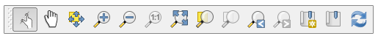

**Map navigation tool bar:** Contains tools to pan or zoom the map canvas.



**Manage layers tool bar:** Contains tools to add vector and raster layers, web map services and several database types. It also contains tools to create new empty layers in Shapefile or SpatiaLite format.

Adding a scratch layer takes you straight into edit mode to add features.



Digitizing tool bar: The digitizing toolbar allows quick and easy editing of vector layers. You can also add new points, lines and polygons to a layer.

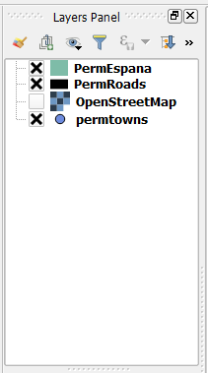

**The Layers Panel**: allows you to see which layers you have loaded, switched on and, with the right click of the mouse, will give you access to the layer properties, table, styling menu and querying menu.

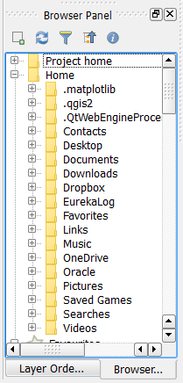

The Browser Panel: This panel allows you to navigate your computer for GIS files that you want to open in QGIS. It is possible to drag-and-drop layers into the canvas to open them.

# Loading Data

QGIS allows you to load a variety of vector data, raster data and to connect to databases.

There are multiple ways to add data to QGIS. For example, you can simply drag and drop files straight into QGIS from windows. You can also use the QGIS Browser, which is similar to ArcGIS’ ArcCatalog.

Once you have your data loaded you can save your project. QGIS uses the extension .qgs; similar to ArcGIS .mxd.

## Vector data:

* Data can be loaded by using the menu tool bar Layer | Add Layer | Add Vector Layer and also using the Add Vector Layer toolbar button. 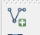
* QGIS can load over 60 different vector formats, including Mapinfo TAB, ESRI shapefiles, AutoCAD DXF and OracleSpatial.

## CSV text files:

* QGIS can load CSV files (and other delimited text files) using the Add Delimited Text Layer option available via the menu by going to Layer | Add Layer | Add Delimited Text Layer or the corresponding toolbar button 
* In the opening dialog make sure you use the right data delimiters for your data (semicolons, tab, commas etc.)
* QGIS will ask you to specify a coordinate system before the data can be plotted.

## Raster data:

* To load raster data, you can click on the **Add Raster Layer** Button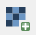, go to **Layer** | Add Layer | Add Raster Layer, or simply drag and drop it from windows.
* ESRI GRID rasters are stored in folders which contain one Info subdirectory and a subdirectory for each GRID. Each GRID subdirectory contains several files that store geographic location and the actual raster data for the corresponding grid. For ArcGIS grid files you will need to load the file w001001.adf or hdr.adf to view it in the canvas. It will not preserve the colour style. More information about the fle structure of Arc/INFO Grids can be found online, e.g. at <https://support.esri.com/en/technical-article/000008526>.

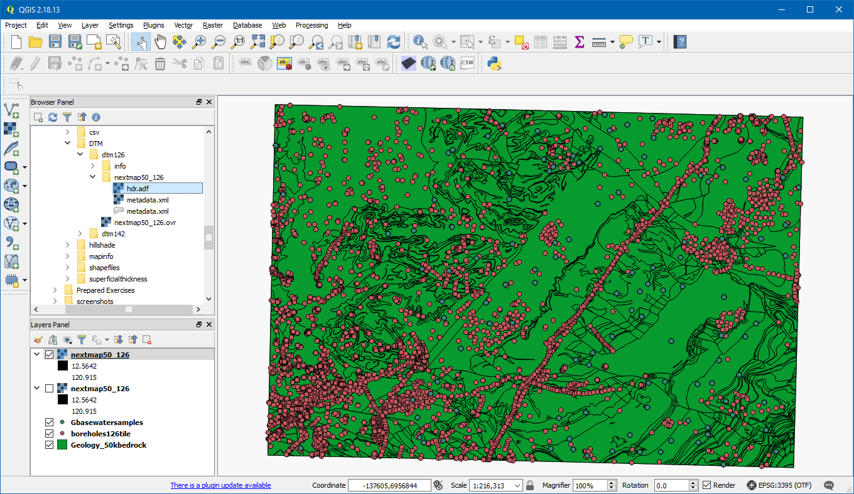

* For mapinfo grids you need to load the file with the extension .grd.
* QGIS can also load Enhanced Compression Wavelet (ECW) files. ECW files are usualy used for satellite and aerial photography and have the .ecw file extension. They can be loaded into QGIS just like other raster files, for example by dragging and dropping an .ecw file into the QGIS window.

## Adding Background data:

* Plugins are small programs that add functionality to QGIS. There is great variety of them accessible through the Plugins menu. They run through the plugin manager, which opens the repository online and keeps track of all the available plugins. We will look in more detail at this later on.

## Exercise: loading data

Open the Exercise data folder. The folder contains several sub-folder with the individual datasets.

1. In the shapefiles folder, load the Geology_50kbedrock.shp and boreholes126tile.shp files (remember to click the **Browse** button, which opens the file-opening dialog. You can select multiple files at once by holding CTRL). Confirm by clicking **Open** twice.
2. Open the Gbasewatersamples.txt file that is located in the csv folder. Have a look in note pad to see the format. Load Gbasewatersamples.txt into QGIS

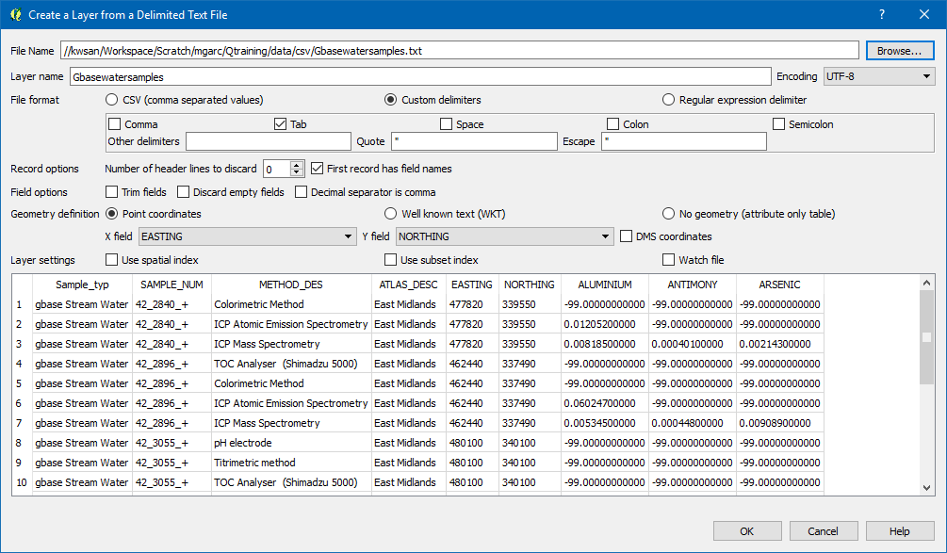

The file uses tabs as delimiters; make sure to set the custom delimiters so “Tab”.

After you click OK, you will be prompted for the data file’s coordinate reference system (CRS). In QGIS’ Coordinate Reference System Selector, you can filter coordinate systems by name or ID code. For the Gbasewatersamples.txt file, we select **OSGB 1936 / British National Grid (ID:27700)**.

1. Load the ESRI GRID raster nextmap50_126, found in the DTM/dtm126 folder. This is a Digital Terrain Model of an area near Nottingham.
2. Load the ESRI GRID raster nextmap50_142, found in the DTM/dtm142 folder. This also a Digital Terrain Model, this on of an area south of Nottingham.
3. Load the ESRI GRID raster sdtm126, found in the superficialthickness folder. This is a map of the thickness of superficial deposits.
4. Load the ECW file SK63.ecw, found in the aerial photograph folder. This is a true colour aerial photograph of an area south of Nottingham.
5. Add the MapInfo file SP_prettypicture (showing the superficial deposits thickness for the Ordnance Survey National Grid area ‘SP’) to QGIS. It’s in the MapInfo folder.
6. QGIS uses project files whose filename ends in .qgs; these are similar to ArcGIS .mxd files and allow you to save a GIS project. Save your project now by going to **Project | Save As…** and save as “exercise 5.qgs” in your training folder.

# Plugins

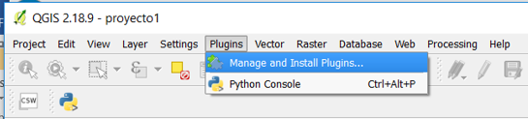

Plugins are small programs that add functionality to QGIS. There are a great variety of them accessible through the Plugins menu. They run through the plugin manager, which opens the online repository and keeps track of all the available plugins.

To install plugins, go to the Plugins menu, and then to Manage and Install Plugins…. This opens the plugin manager, where you can find, download, install and uninstall plugins.

To filter the list of available plugins, simply start typing in the Search box at the top of the window. Then, click on the plugin you wish install to highlight it, and then click on the Install Plugin button.

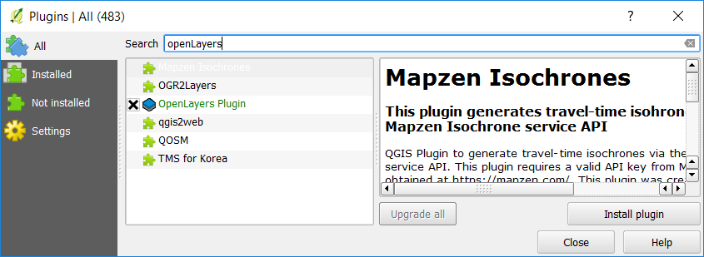

## Loading background maps

Background maps are very useful for quick checks and to provide orientation, especially if you don't have access to any other base layers. Adding background maps is easy with the help of the **QuickMapServices** plugin. It provides access to satellite, street, and hybrid maps by different providers.

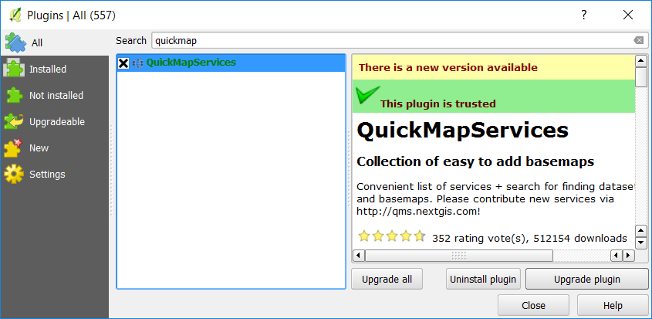

Search and select it from the list and click on Install plugin. This is going to take a moment. Once it's done, you will see a short confirmation message. You can then close the installer, and the QuickMapServices plugin will be available through the **Web** menu.

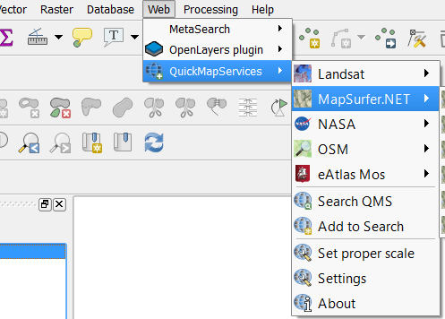

These services provide their maps only in Pseudo Mercator (EPSG: 3857); QGIS should change the project CRS automatically; if not, make sure that yours is set correctly.

An alternative to the QuickMapServices plugin is OpenLayers **Plugin**, which provides similar functionality. Both the QuickMapServices as well as the OpenLayers plugin, once downloaded, are available through the web menu.

## Exercise: Background Map

1. Open the project Exercise 5.qgs and Install and activate the QuickMapServices plugin or the OpenLayers plugin.
2. Add the OpenStreetMap (OSM) standard map to your project.
3. Navigate to Keyworth using the zoom tools.
4. Add other layers from the QuickMapServices plugin and have a look at the data.
5. Save your project as Exercise 6.qgs

# Coordinates/Projection

## On the Fly CRS transformation

Whenever QGIS does not know a dataset’s Coordinate Reference System, it prompts the user with the Coordinate Reference System Selector, where you can manually select the layer’s CRS.

QGIS has On-The-Fly Reprojection. This means that we can load datasets with differing CRSs and they will be displayed correctly. You can change the CRS used for displaying data either by going to **Project** | **Project Properties**, or by clicking on the **CRS status** button (with the globe symbol and the EPSG code right next to it ) in the lower right corner of the main window. Note that this can slow down your machine if you are working with large datasets that have to be reprojected.

To enable “on the fly” projection, click on the CRS Status button in the Status Bar along the bottom of the QGIS window:

* In the dialog that appears, check the box next to Enable ‘on the fly’ CRS transformation. (located at the top of the window menu)

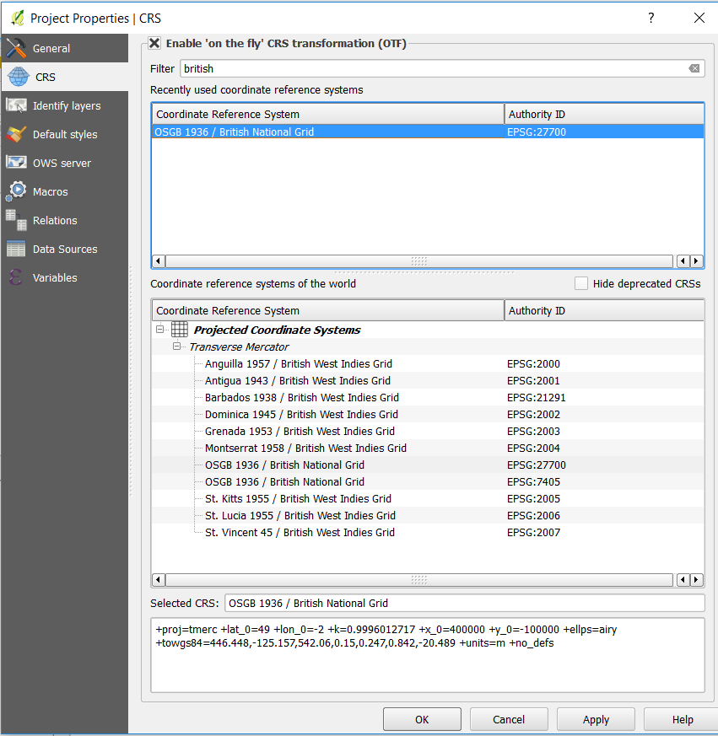

* To change the CRS, select it from the list and click OK. To search for a specific CRS, type the name or ID into the textbox labelled “Filter”. For example, the British National Grid we use in BGS has the EPSG ID 27700.

## How to save data to another CRS

‘On the fly’ does what it says - it doesn’t change the data, it just reprojects the layers as they appear on the map. To truly reproject the data itself, you need to export it to a new file using a new projection.

Start by saving the layer with another name and changing its properties:

* Right-click on the layer in the Layers list and select Save As. Click on the Browse button next to the File name field and specify the location and name of the new layer i.e. data_reprojected.shp.
* Change the value of the Layer CRS dropdown to Selected CRS. Click the Browse button to open the CRS Selector dialog and sear for British in the filter field. Choose British national grid from the list.
* Leave everything else unchanged. The **Save vector layer as...** dialog now looks like fig…

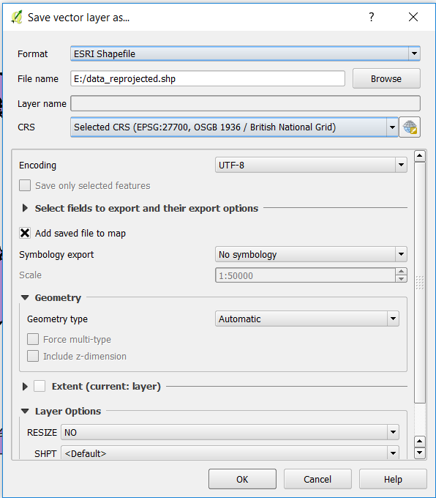

## Exercise: Projection

1. Open project Exercise 6.qgs
2. Zoom out to the world.
3. Change the project CRS to British National Gird (ID: 27700) and observe how it changes how GIS data is displayed.
4. Zoom in to the UK. You will notice the data is ok for the UK.
5. Change the project CRS to WGS 84 / Pseudo Mercator (ID: 3857). This is the CRS used by many web maps such as Google Maps and OpenStreetMap.
6. Zoom out to the world to see the data is projected ok again.
7. Save the layer Gbasewatersamples as Water_reprojected.shp in CRS WGS 84 / Pseudo Mercator (ID: 3857).
8. Check in the layer properties the CRS again for both water samples.
9. Save project as Exercise 7coor.qgs

# Styling Data

## Styling Raster Layers

QGIS offers several options for styling raster layers, for example Multiband colour, Palletted, Singleband Gray and Singleband Pseudocolor. This can be changed in the **Style** tab in the **Layer Properties** window under **Render Type**.

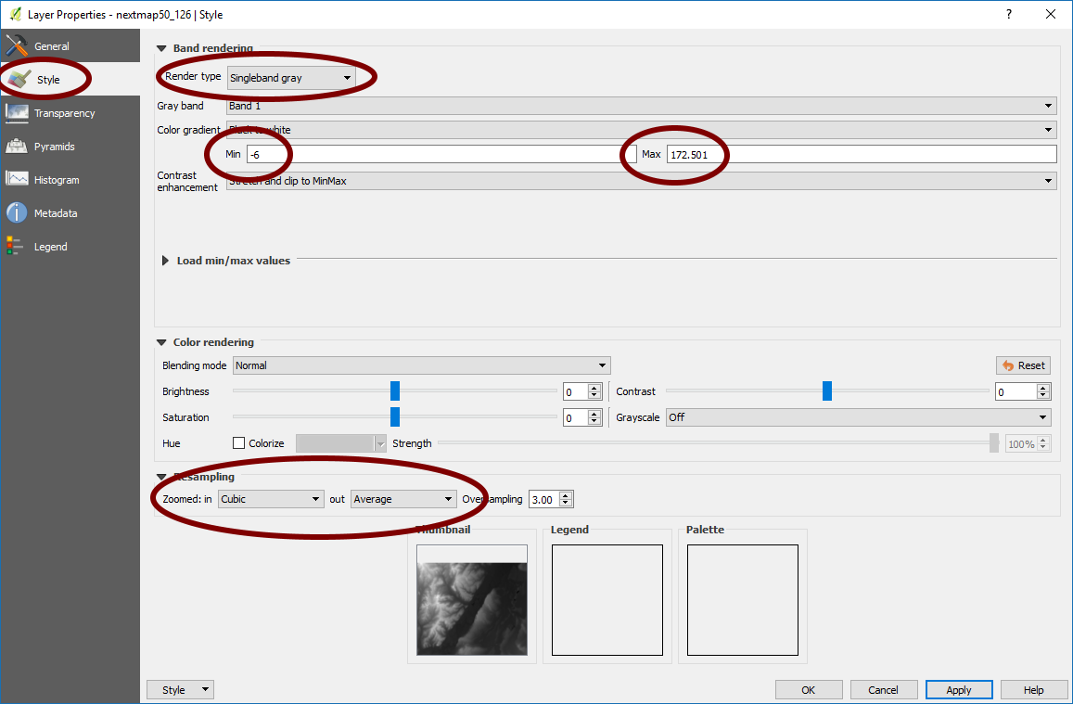

Below the colour settings, we find a section with more advanced options that control the raster **Resampling**, **Brightness**, **Contrast**, and **Saturation**. By default, resampling is set to the fast **Nearest neighbour** option. We can change to the **Bilinear** or **Cubic** method. This will make the image look less jagged when zoomed in.

We can also set the minimum and maximum values of the colour gradient; for example, for our DTM nextmap50_126 layer (where the pixel values represent height in metres) QGIS has extracted the minimum and maximum pixel values in the layer. Thus, a value of 12.56 is shown as black, while a value of 120.91 is shown as white, with values in between shown as shades of grey.

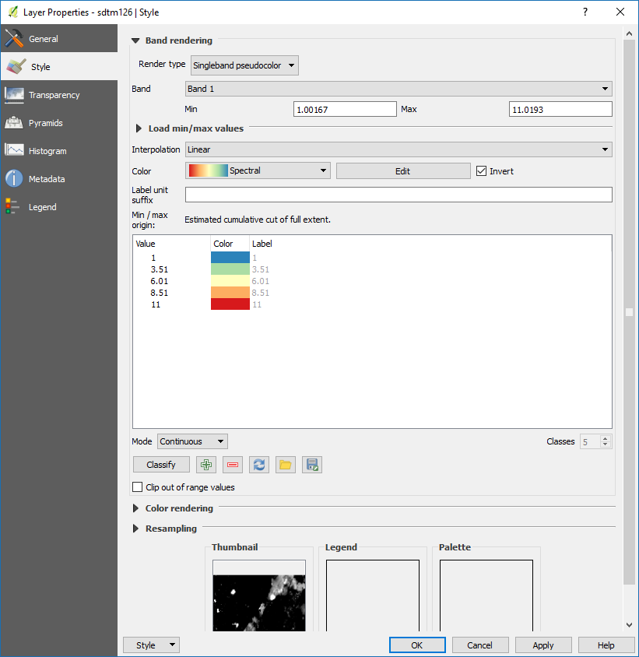

### Hillshading

A convenient feature of QGIS is that it can also create hillshading on the fly. This can be done by changing the **Render Type** of a layer to **Hillshade** in the layer’s properties window. Various settings in how the Hillshade is displayed can be changed in the same window. For example, the **z-factor** determines how much the height is exaggerated when displayed.

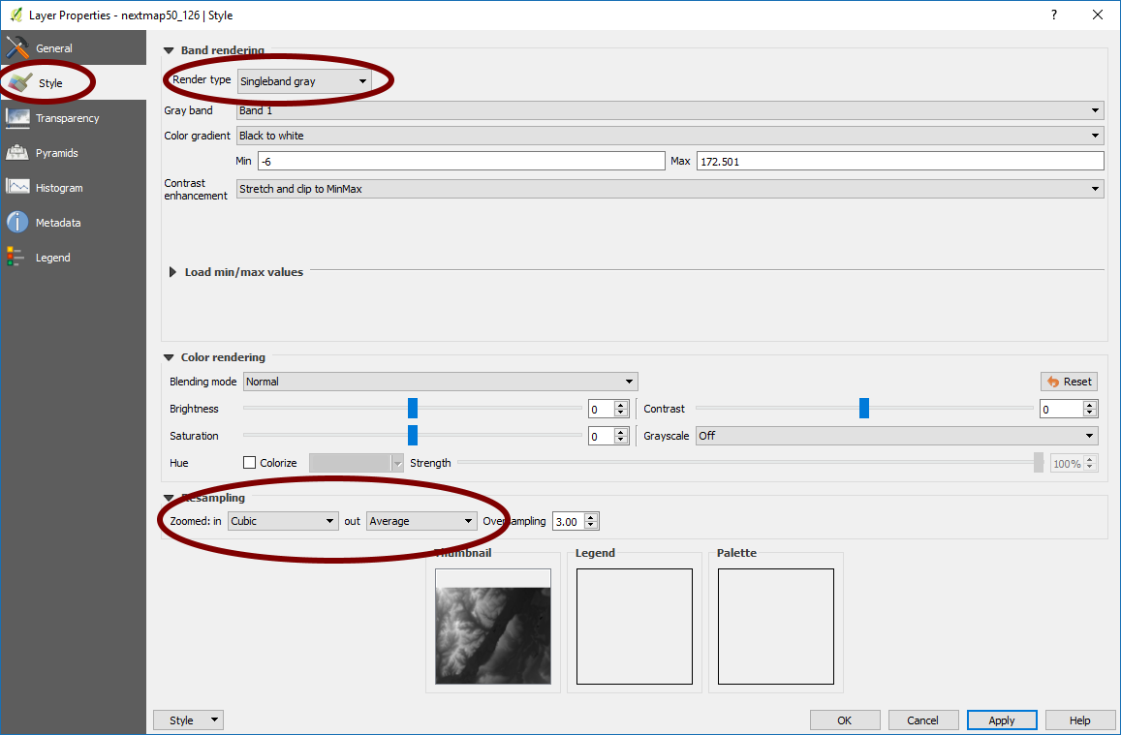

### Blending Modes

Blending modes allow us to determine in great detail how overlapping layers are displayed, and allow far more fine control than simply changing the transparency of a layer. Blending modes can be changed in a layer’s properties window. For example, the Multiply blending mode will Make it so that lighter areas of the layer will become transparent to the layer underneath.

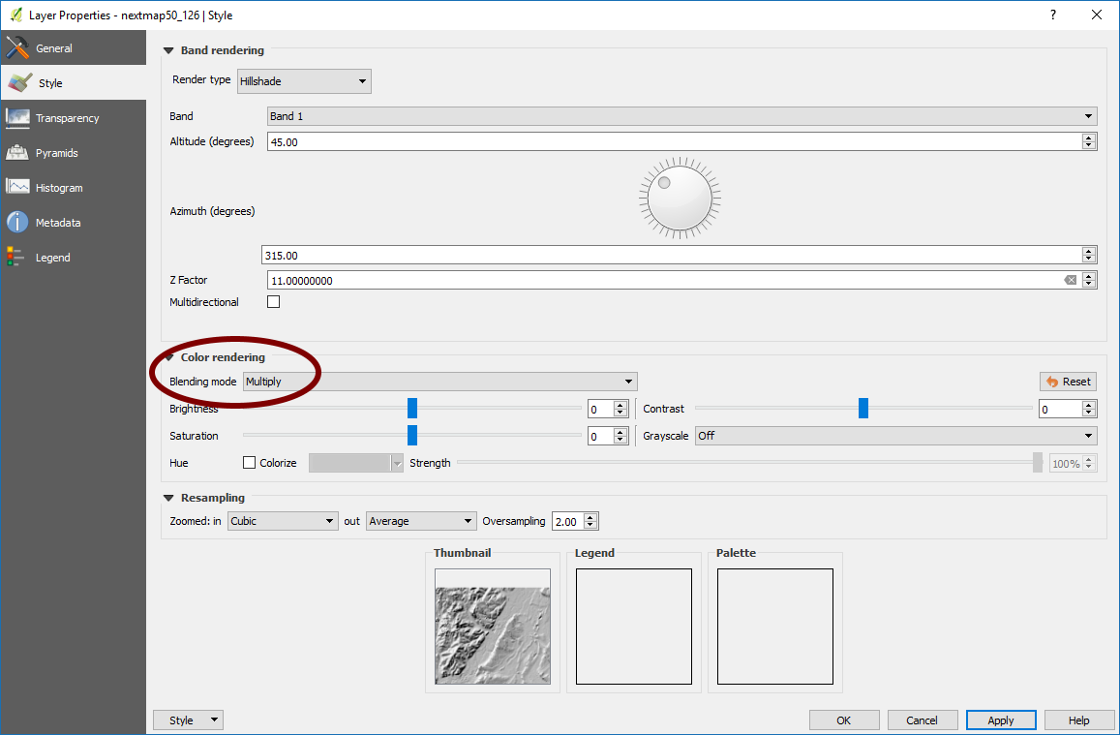

## Styling Vector Layers

Vector symbology can be extensively customized in QGIS. Not only can QGIS automatically categorize symbols based on the attribute table, it can also apply colour ramps to symbols.

In a vector’s Style tab in its Layer Properties window, you can use the dropdown at the top to select how you want to display the layer. **Categorized** will allow you to automatically categorize vector data based on their attributes, while **Graduated** will allow you to apply colour ramps to linear data. This is done by selecting a data column in the **Column** dropdown menu and the clicking on the button labelled **Classify**.

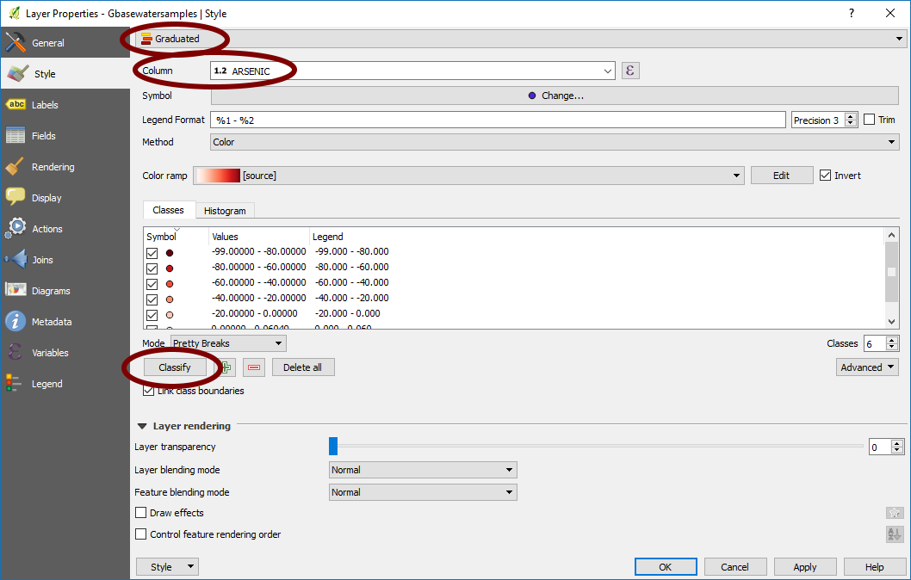

## Saving Layer Styles

QGIS can save layers and their styles so that you do not have to redo the styling whenever you add the same data. To save a Layer Definition File, simply right click on the layer and select Save As Layer Definition File…. This creates a .qlr file that contains the path to the layer as well as any display and styling options you have chosen for that layer. You can also save groups of layers the same way.

To open a definition layer you need to go through the Layer menu at the top and select Add from Layer definition file.

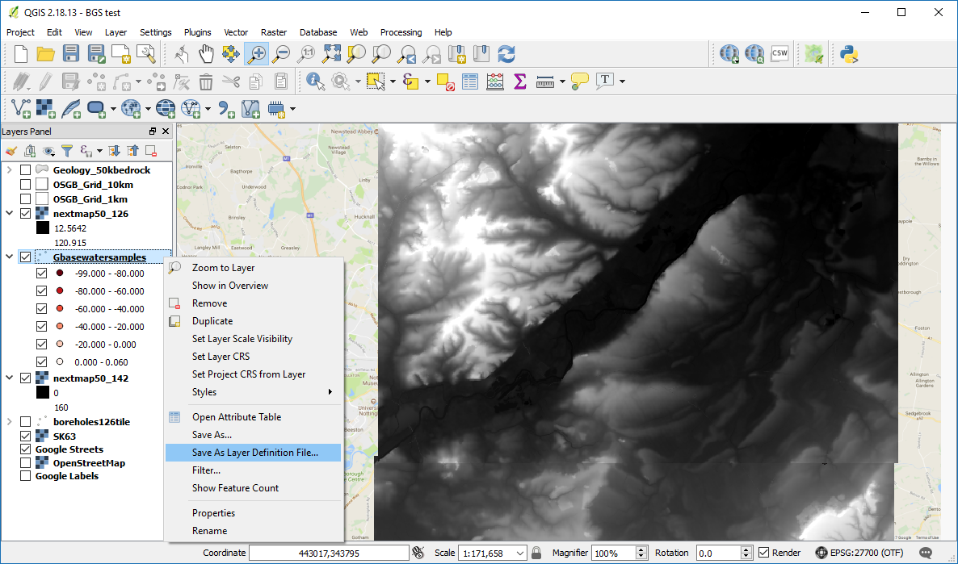

QGIS can save paths as either relative or absolute. This can be set in the Project Properties window which can be reached by going to Project | Project Properties.

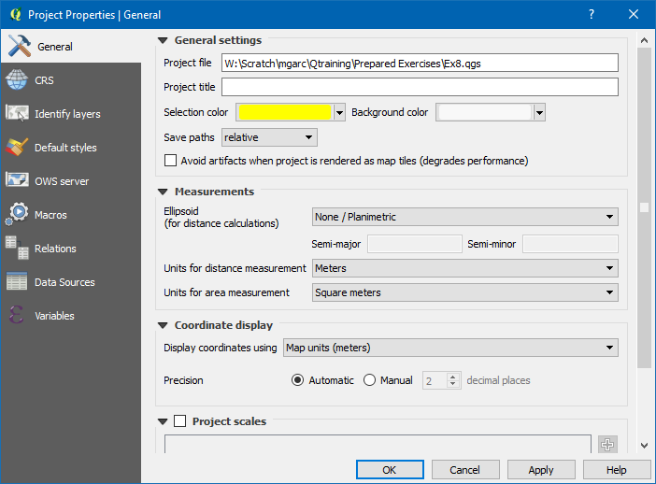

You can also save and apply styles themselves. For example, if you have made a complex point marker that you wish to apply to other point layers in the future, you can save this as a QGIS Layer Syle File (.qml). To do so, go to a layer’s Properties window. Under the Style tab, you will find a button in the lower left corner labelled Style. Click on it and select Save Style.

## Exercise: Raster Styling

1. Open exercise 7.qgs
2. In the **Layers Panel**, move **sdtm126** so that it is the topmost layer. Zoom to layer.
3. Modify **sdtm126** so that it is displayed as **Singleband Pseudocolor**. You should now see the thickness of superficial deposits displayed in colour, rather than black and white.
4. Zoom to nextmap50_142 **.** Modify nextmap50_142so that it is displayed as a Hillshade layer with a Z Factor of 5. Keep the Blending Mode set to Normal. Notice that the layer remains opaque to other layers under it.
5. Change the Blending mode to be multiply. Can you see now the topo underneath?

## Exercise: Vector Styling

1. Move the layer **Gbasewatersamples** to the top of the layers in the Layer Panel and change it so that it displays the levels of arsenic in graduated colours.
2. Change the **Geology_50kbedrock** layer so that is categorized by the column RCS_D. Also change its blending mode to Multiply. You should be able to see that the layer has become multicoloured and partially transparent.

## Exercise: Saving Styles

1. Save the Gbasewatersamples layer as a layer definition file. Then, remove the layer and add it again using the layer definition file you have created. (layer/Add from layer definition file)
2. Save your project as Exercise 8.qgs

# Spatial Joins

Spatial joins allow us to combine the attribute tables from two datasets based on their location.

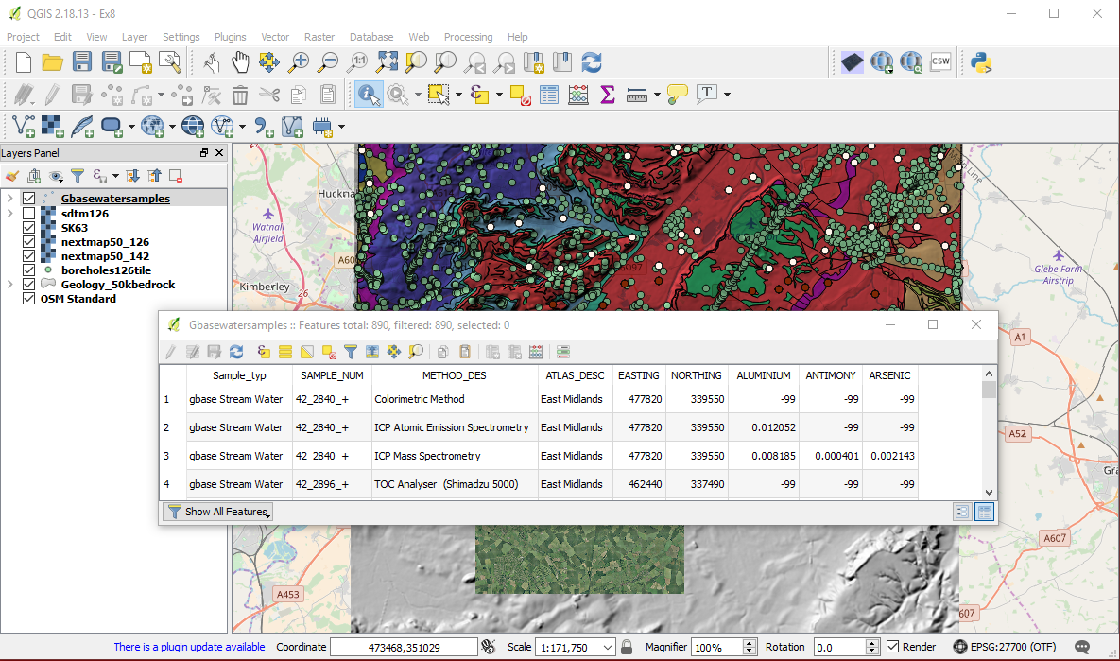

To spatially join two datasets, go to Vector | Data Management Tools | Join attributes by location.

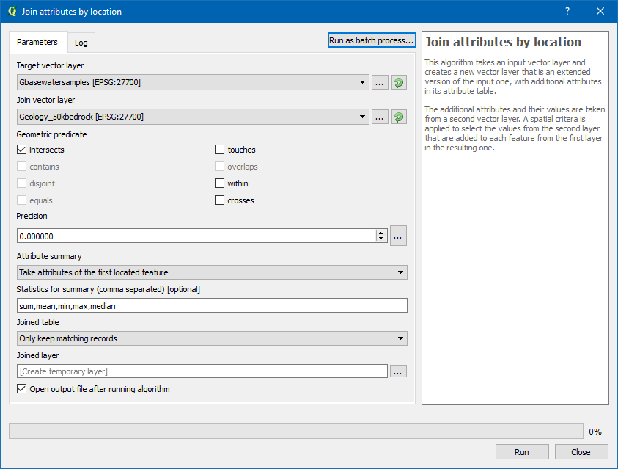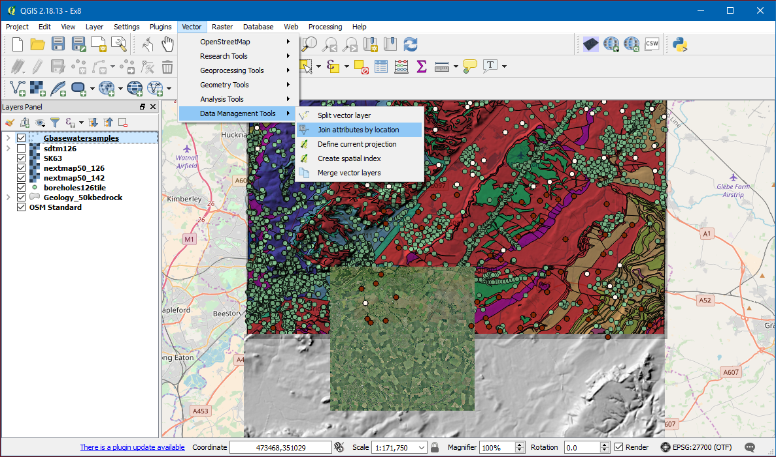In the new window, select the “Target vector layer” to be the layer that you wish to add more attributes to and the “Join vector layer” to be the layer from which you wish to take attributes. The spatial join tool allows us to specify a variety of geometric tests for our data, so that we can, for example, look at only those features which are entirely contained within another feature.

## Exercise: Spatial Join

Imagine that we wish to investigate whether there is a relationship between a stream’s Aluminium levels and the type of the underlying bedrock. The water sample dataset does not contain any information about the underlying rock, and the geology dataset does not contain any information about the water samples.

Spatially join the Gbasewatersamples layer and the Geology_50kbedrock layer:

1. Make sure that you have both the Gbasewatersamples point layer and the Geology_50kbedrock polygon layer open in QGIS.
2. Go to Vector | Data Management Tools | Join attributes by location.
3. Set the Gbasewatersamples point layer as your target layer; this means that will be copied and have the attributes from the polygon layer appended.
4. Set your join vector layer to Geology_50kbedrock.
5. For the geometric predicate, select “Intersects”.
6. After running the spatial join tool, open the attribute table of the new layer. Observe how this layerattribute table now contains both water sample data as well as geological data

# Selecting Data

## Selecting with the mouse

You can select features with the mouse using buttons found the **Attributes** toolbar, or in the menu under **View | Select**. Thus, you can for example, select all points within a certain radius of a place.

## Selecting with expressions

You can also select features based on expressions that can contain references and functions that use feature attributes and/or geometry. To do so, highlight the appropriate layer and go to **View | Select | Select by Expression…** or click on the appropriate button on the toolbar.

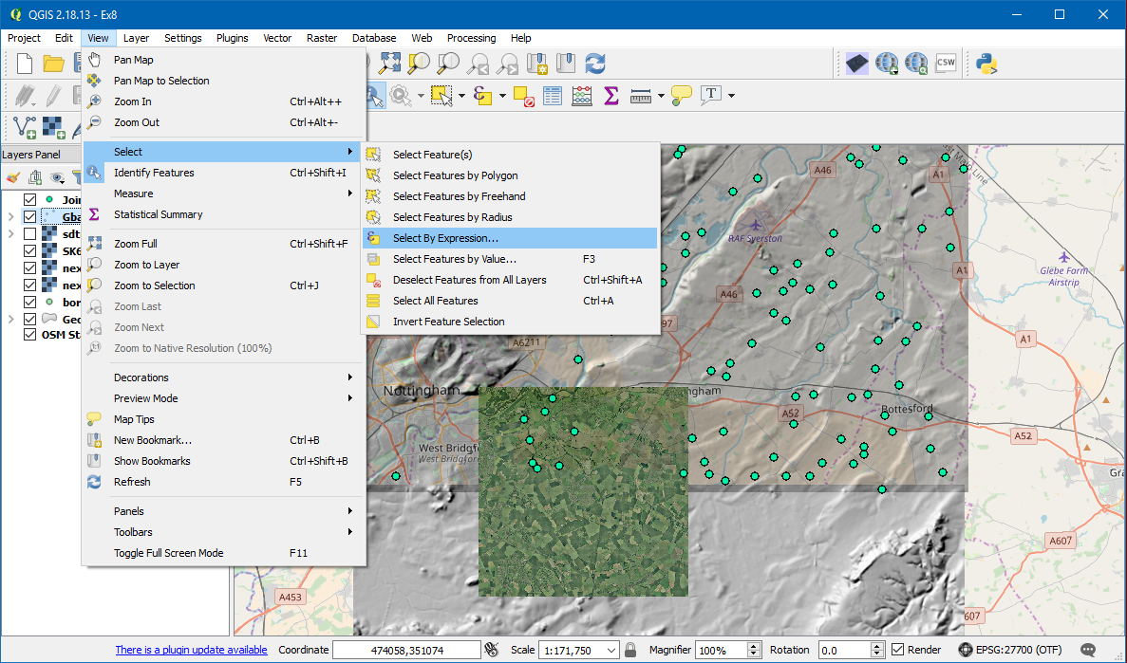

This will bring up the Select by Expression window. Here you can type SQL queries to select features, using a variety of functions and fields. The column headings of the layer’s attribute table can be found in the section “Fields and Values”. For example, to select boreholes with a length greater than 20, we would type “LENGTH” > 20 into the textbox on the left.

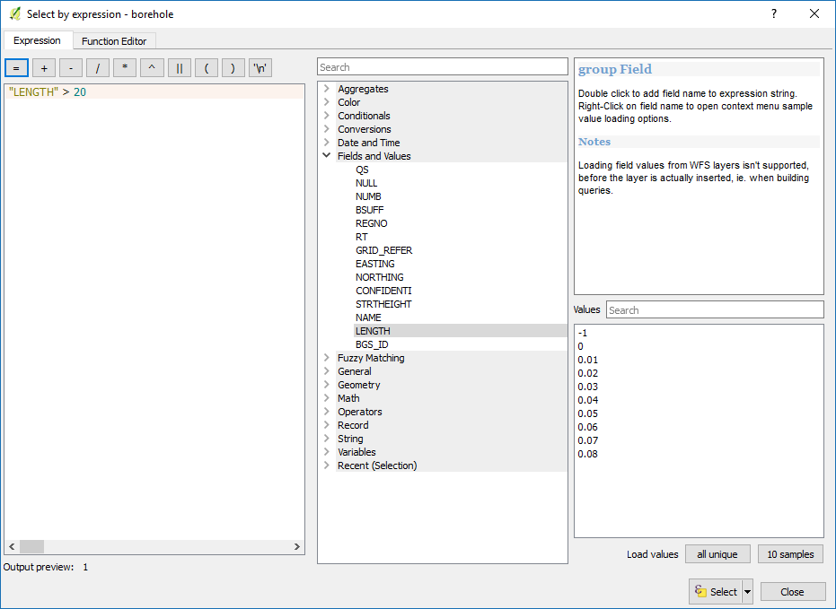

By opening the Fields and values menu on the right,we will be able to see the fields names and a sample of their values or all the unique values. This is very useful when writing your SQL.

## Selecting with filters

Another way of selecting features is by using filters. To do so, open the layers table. Right click on the layer and select **Open attribute table.**

At the top of the table you can see how many features have been selected.

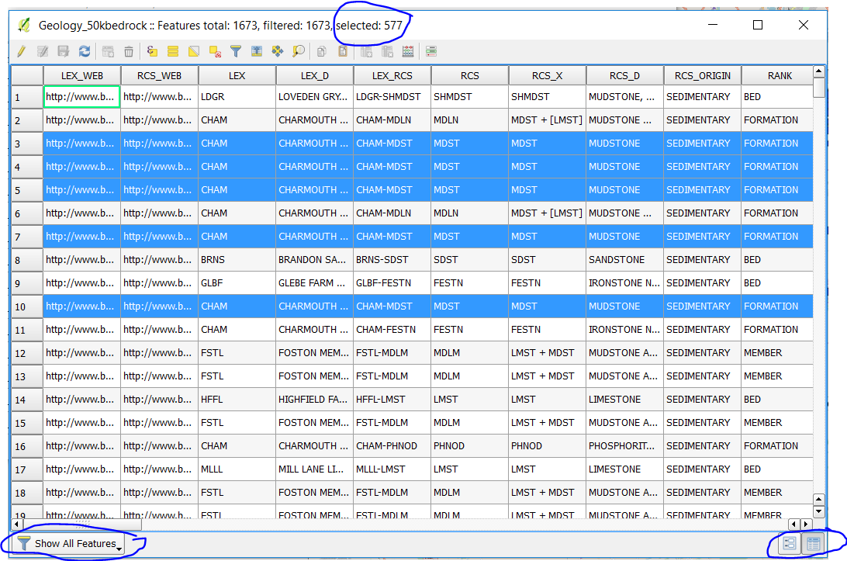

Using the filtering tool  will open a new window where you can specify the parameters of your selection. **Greater than, equal to,** etc

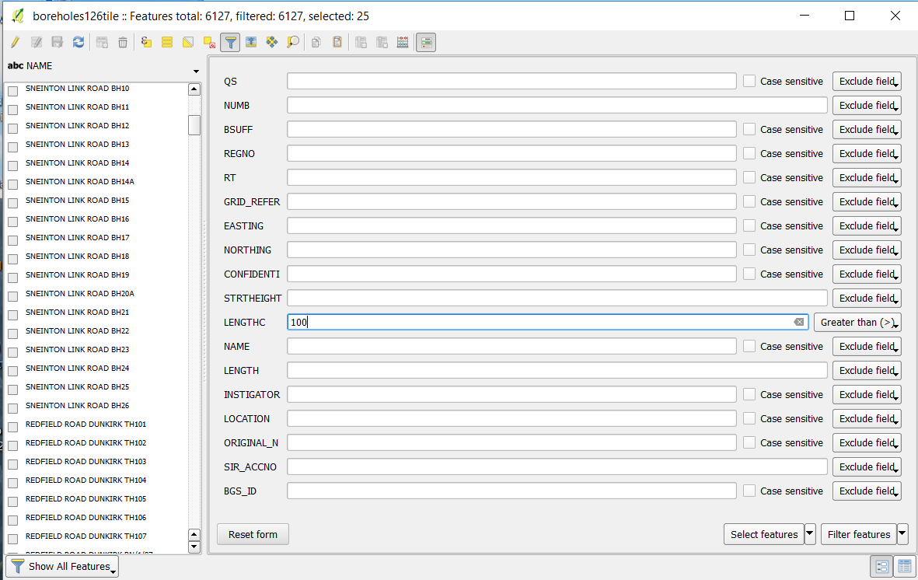

There is a menu on the bottom left that allows you to apply diferent filtering methds such us **see only the selected** features. 

The tools on the bottom right will allow you to navigate between the filtering tool menu and the attribute table. 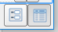

A very useful tool is the **move selection to the top** tool 

## Atribute table tools

When opening the attribute table we will have a series of tools at the top.

We have already seen the select by expression and the filtering tool.

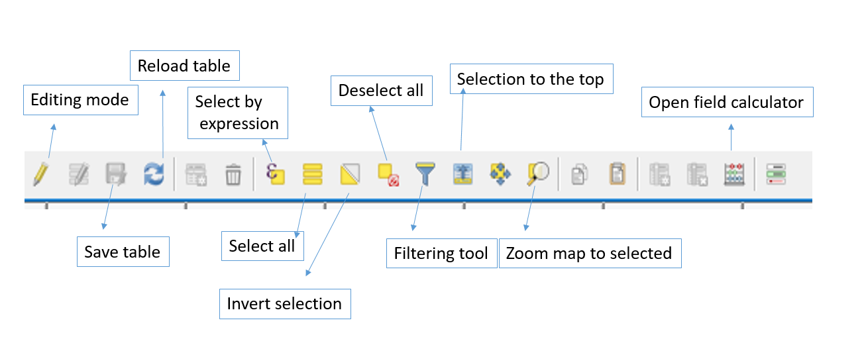

## Exercise: Selecting Data

1. In the Layers Panel, move the layer boreholes126tile to the top.
2. Select all boreholes with a length greater than 100 metres. How many did you find? Answer: 308
3. How many of those are confidential boreholes? Answer: 25.
4. Practise selecting other data:

Select from the geological map all the MDST in the field RCS.

* + 1. Where RCS field contains MDST.
    2. Where the RCS field is equal to MDST.

1. Practise using the other tools in the attribute table, for example the “field calculator” or the “zoom to selected” button.

# Data Creation and Editing



## Creating a New Vector Layer

Go to **Layer | Create Layer | New Shapefile Layer…**. This opens the **New Shapefile Layer** dialog with options for different geometry types, CRS, and attributes. By default, the tool will create a new point layer in WGS84 (EPSG:4326) CRS (unless specified otherwise in **Settings** | **Options** | **CRS**) and one integer field called **id**.

Click **OK**; you will be prompted to name your file and save it. Afterwards, QGIS will automatically load it.

## Adding/Digitizing data

The new layer is empty. If we want to add features to a layer, we first have to enable editing for that particular layer. Editing can be turned on and off by any one of these ways: going to **Layer** | **Toggle editing**, using **Toggle editing** in the layer name context menu, or clicking on the **Toggle editing** 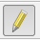button in the **Digitizing** toolbar. The layer’s icon in the Layers Panel will change to reflect whether editing is turned on or off.

To add features to the map, go to **Edit | Add Feature**. We can then add features simply by clicking on the map. When you click, you will be prompted to fill in the attribute form; do so, and click **OK**.

To finish editing, either click on the **Toggle Editing** button in the **Digitizing Toolbar**, under **Layer | Toggle Editing**, or by right-clicking on the layer. You will be prompted to save your edits.

## New scratch layer

A scratch layer can be created by going to **Layer | Create Layer | New temporary scratch Layer…**. In the menu that opens choose the geometry you need, and give it a name.

The scratch layers are already in edit mode, ready to start digitizing. By opening the attribute table you can now add fields to the table using the new field tool 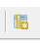. This way you can start attributing your objects as you digitise.

Temporary layers are not saved and will be discarded when QGIS is closed. To save the layer as permanent one, right click on the layer and select save as. After this you can safely remove the temporary layer from your project.

## Exercise: digitising

1. Open a brand new project
2. Add the open street layer
3. Create a point layer called cities. Digitize 3 points (E.g. Nottingham, Bingham, Keyworth)
4. Create a line layer called roads using the new scratch layer. Add a number field called road_num. Digitise 3 roads to join the cities and give them road numbers.
5. Have a go at styling the layers.
6. Save project as exercise 11.qgs

# Print Composer

A GIS map file is not an image. Rather, it saves the state of the GIS program, with references to all the layers, their labels, colours, etc. So for someone who doesn’t have the data or the same GIS program (such as QGIS), the map file will be useless. QGIS can export its map file to a format that is easier to read in any computer or print out. Both exporting and printing is handled via the Map Composer.

## Save as Image

QGIS allows you to quickly and easily save a georeferenced image of the data on your map canvas. To do so, go to Project | Save as image.

## Print Composer

To create a map layout you use a print composer. To start with the project doesn’t have any. You can add one or several by using ctrl+P or by selecting New Print Composerfrom the Project menu.

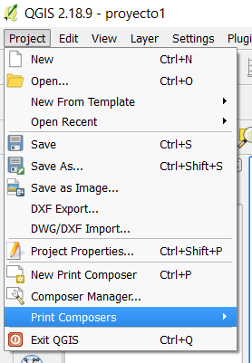

The print composer is like the layout layer in ArcMap.

In the composition tab you can set up the page size, orientation dpi quality, etc.



Pan composer

Zoom

Select and move item

Move item content (the map data)

Edit nodes item

Add New map

Add image

Add new label

Add new legend

Add new scale bar

Add shape

Add nodes item

Add arrow

Add attribute table

Add HTML frame



To add the data use the Add new map tool  to draw a rectangle in your paper.

To zoom in an out of the map use these buttons 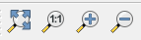

When zooming in, the map view will not refresh by itself. This is so that it doesn’t waste your time redrawing the map while you’re zooming the page to where you want it, but it also means that if you zoom in or out, the map will be at the wrong resolution and will look ugly or unreadable.

Force the map to refresh by clicking this button:

To add a title click on the “add new label” button. 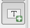 and click on the canvas to add a text box. You can change the text, font and other properties in the “Item properties” tab on the right side of the screen.

It is possible to align frames by selecting two or more frames and using the align tools. 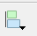

When you create a print composer and make changes to it, these changes are saved as part of your project.

## Exercise: print map-layout

Create your own layout page:

1. Open Exercise8.qgs
2. Add a map
3. Add a title
4. Add a legend
5. Test how the align tool works
6. Set to print as A4, landscape and to 300dpi
7. Export the map as a pdf

# Plugins

Plugins allow you to extend the functionality QGIS offers. QGIS allows you to easily download and install plugins from online repositories using the Plugin Manager.

To open the Plugin Manager, click on the menu item **Plugins | Manage and Install Plugins**.

In the dialog that opens, find the **Processing** plugin:

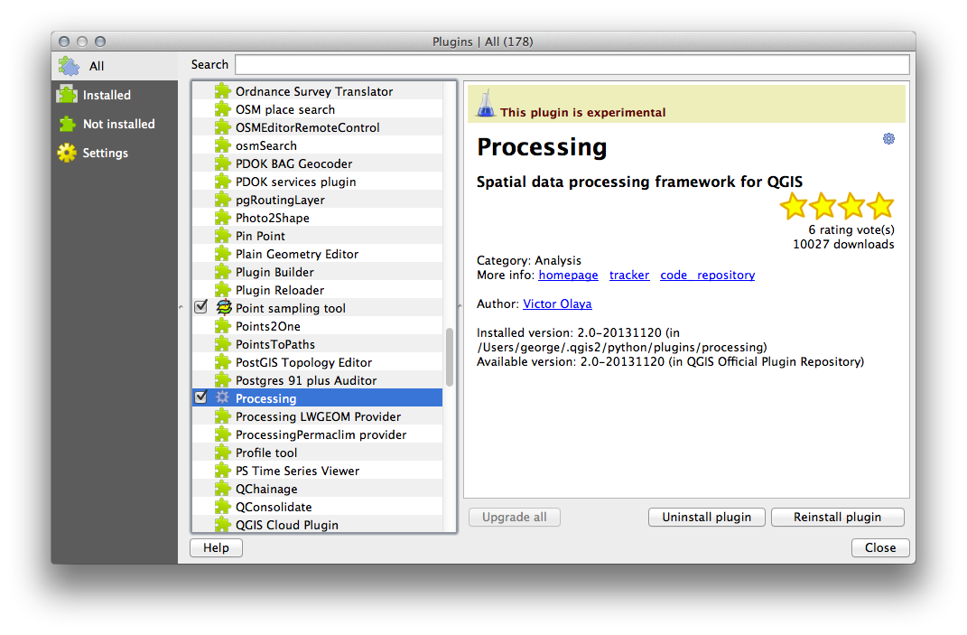

* Click in the box next to this plugin and uncheck it to uninstall it. Click Close.
* Looking at the menu, you will notice that the Processing menu it is now gone. This means that many of the processing functions you have been using before have disappeared! This is because they are part of the Processing plugin, which needs to be activated for you to use them.
* Open the Plugin Manager again and reactivate the Processing plugin by clicking in the checkbox next to it and clicking Close.
* The Processing menu should be available again.
* The list of plugins that you can activate and deactivate draws from the plugins that you currently have installed.
* To install new plugins, select the Not Installed option in the Plugin Manager dialog. The plugins available for you to install will be listed here. This list will vary depending on your existing system setup.
* You can find information about each plugin by selecting it in the list of plugins displayed.
* A plugin can be installed by clicking the Install Plugin button below the plugin information panel.

The plugins that are available to you for installation depend on which plugin repositories you are configured to use. By default, only the official repositories are active, meaning that you can only access official plugins. These are usually the first plugins you want, because they have been tested thoroughly and are often included in QGIS by default.

## Useful QGIS Plugins

Let’s look at some examples of useful plugins.

* The Raster Terrain Analysis Plugin
* The GeoSearch Plugin

### The Raster Terrain Analysis Plugin

The Raster Terrain Analysis Plugin can be used to calculate the slope, aspect, hillshade, ruggedness index and relief for digital elevation models (DEM). It is very simple to handle and provides an intuitive graphical user interface for creating new raster layers

Description of the analysis:

**Slope**: Calculates slope angle for each cell in degrees (based on first order derivative estimation).

**Aspect:** Exposition (starting with 0 for north direction, in degrees counterclockwise).

**Hillshade**: Create shaded map using light and shadow to provide a more three-dimensional appearance for a shaded relief map.

**Ruggedness Index:** A quantitative measurement of terrain heterogeneity as described by Riley et al. (1999). It is calculated for every location, by summarizing the change in elevation within the 3x3 pixel grid.

**Relief**: Creating a shaded relief map from digital elevation data. Implemented is a method to choose the elevation colours analysing the frequency distribution.

* This plugin can be accessed by opening the Plugin Manager and checking that the Raster Terrain Analysis plugin is enabled. **Plugins | Manage and Install Plugins**.

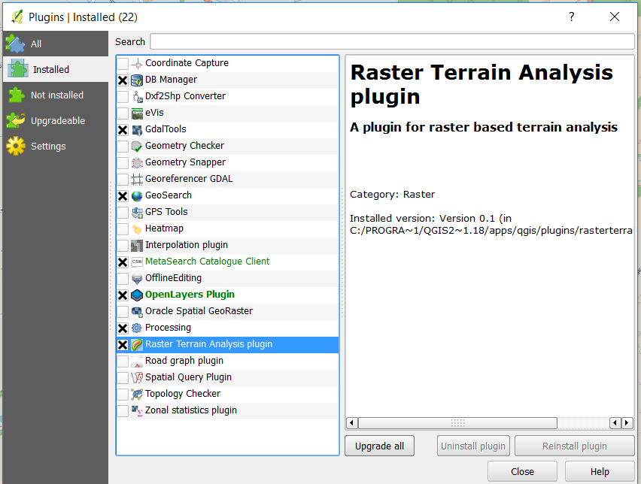

### Exercise: Raster Terrain Analysis

* Open the nextmap50_142 DTM raster.
* Open the Raster menu. You should see a Terrain analysis submenu.
* Click on **Terrain analysis | Relief**
* Save the new file under exercise_data/plugins/test142relief.tif (create a new folder if necessary).

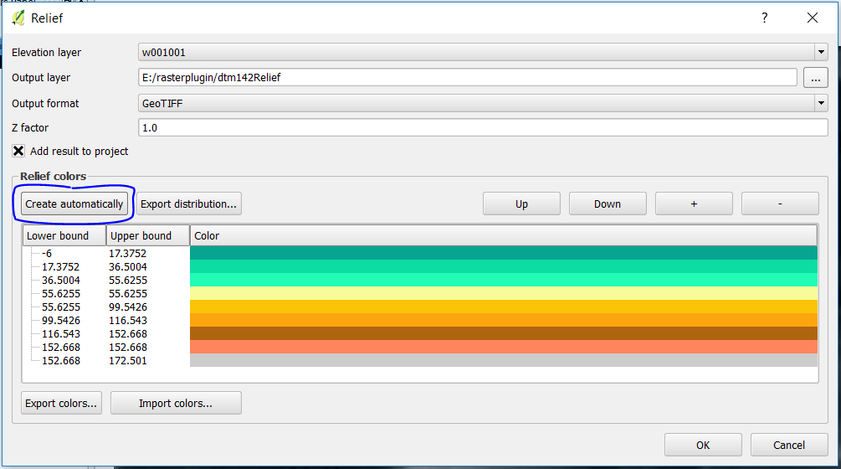

* Leave the Output format and Z factor unchanged.
* Make sure the Add result to project box is checked.
* Click the Create automatically button. The list will be populated. These are the colors that the plugin will use to create the relief. Colors can be change by double-clicking on each row’s color bar. For example:

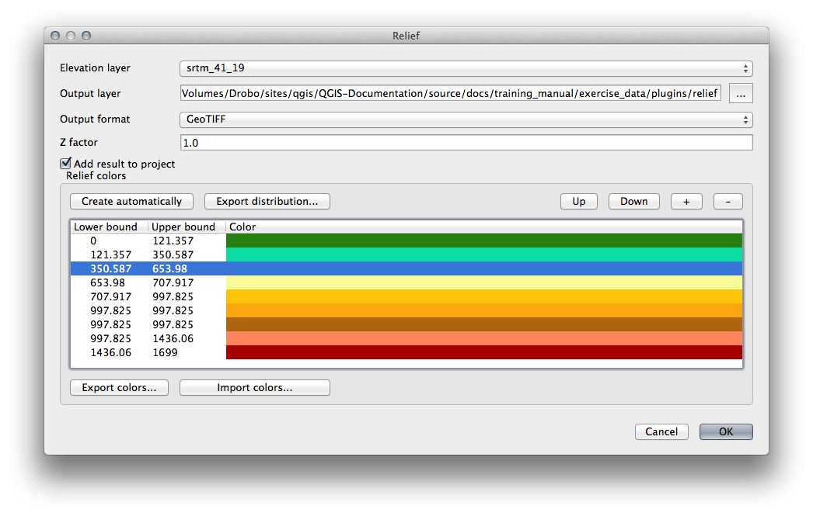

* Click OK and the relief will be created:

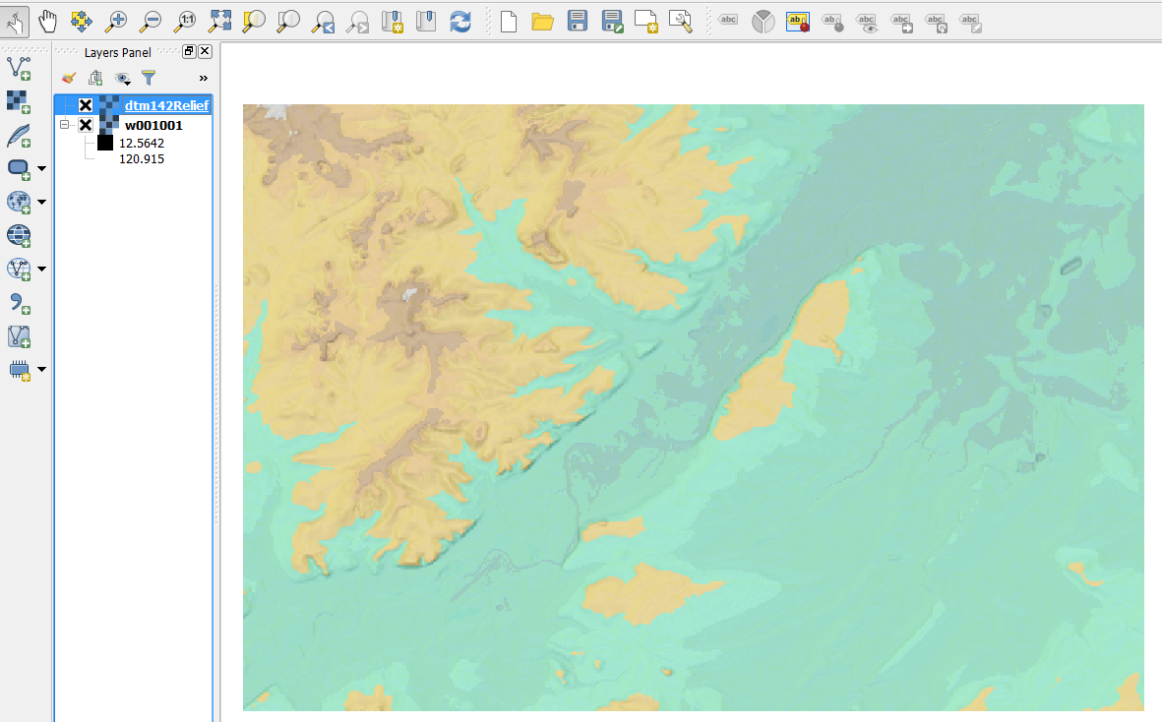

This achieves a similar effect to when you used the semi-transparent hillshade as an overlay over another raster layer. The advantage of this plugin is that it creates this effect using only one layer.

### The GeoSearch Plugin

The GeoSearch plugin gives geocoding, address searching, and routing functionality. Each search you perform can be dynamically saved as a layer.

Search location(with elevation) by words or point like google map; Calculate Distance with bearing between two points on the map Canvas.; Draw Route with multi ways points by google maps service.

### Exercise The GeoSearch plug in

* Start a new map with no datasets.
* Open the Plugin Manager and filter for the GeoSearch Plugin and click Install Plugin to install it.

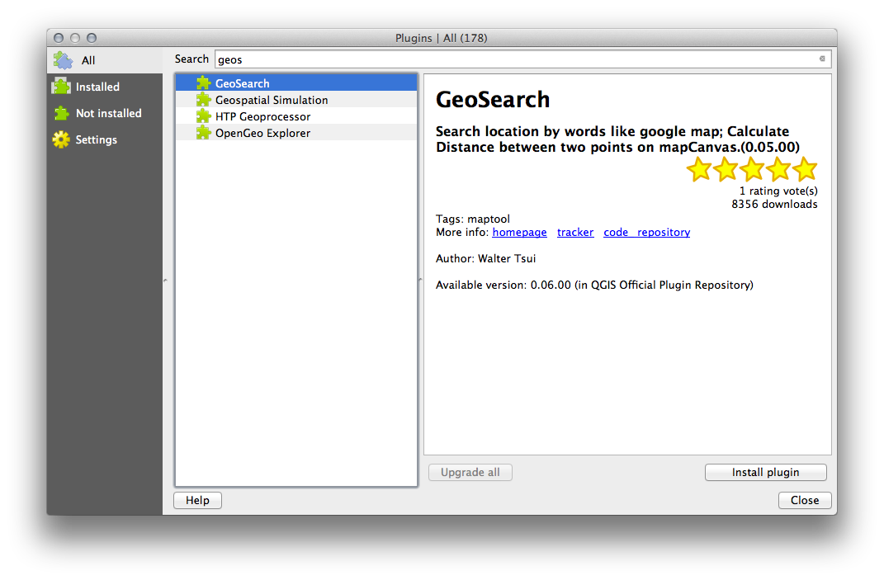

* Close the Plugin Manager.
* Load the open street map (**Web | QuickMapServices | OSM | OSM Standard)**
* You can now use the GeoSearch plugin to search for placenames. Click on **Plugins | GeoSearch | GeoSearch** to open the GeoSearch dialog.

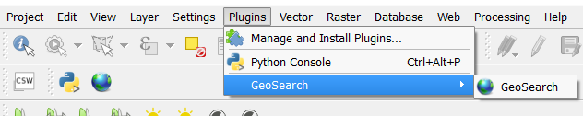

* Search for keyworth in the GeoSearch Dialog to locate it on your map.
* Try and search for places all over the world.

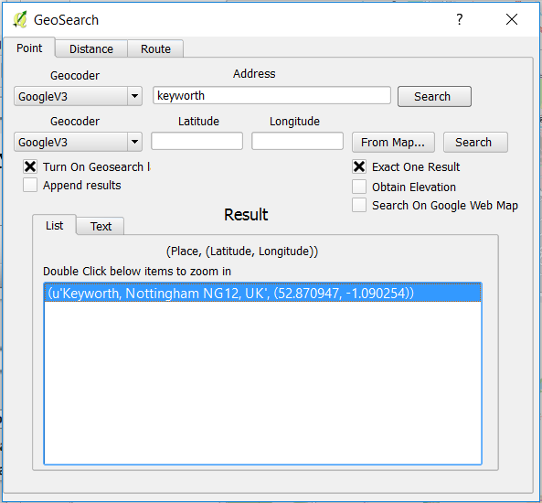

### The MMQGIS plugin

“MMQGIS is a set of Python plugins for manipulating vector map layers in Quantum GIS: CSV input/output/join, geocoding, geometry conversion, buffering, hub analysis, simplification, column modification, and simple animation. MMQGIS provides an alternative to the Processing toolbox, with verbose progress reporting, an intuitive user interface, direct shapefile/CSV-file access, and some additional capabilities missing from other plugin sets.”

More information and usage examples can be found at: http://michaelminn.com/linux/mmqgis/

# Connecting to databases

QGIS can also connect to spatial databases such as Oracle Spatial to get data. To add data from the BGS oracle database, go to **Layer | Add Layer | Add Oracle Spatial Layer...**.

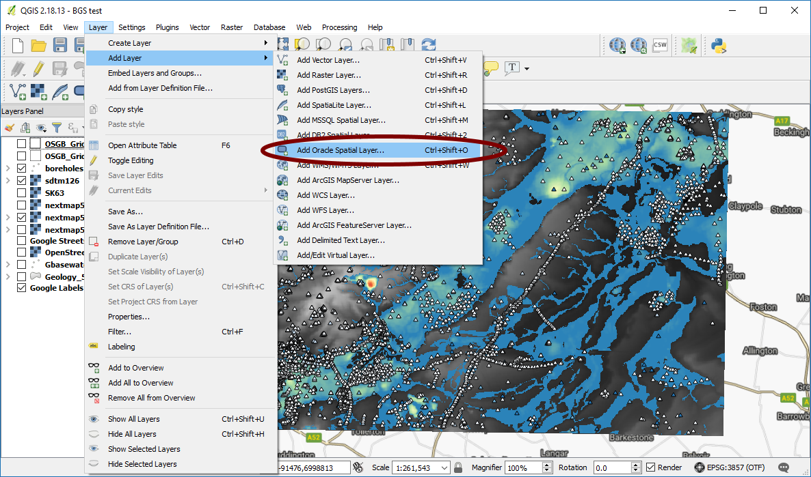

This will bring up the Add Oracle Table(s) Window. Here you can select which connection to use (allowing you connect to various different databases using different user accounts) and which table to use.

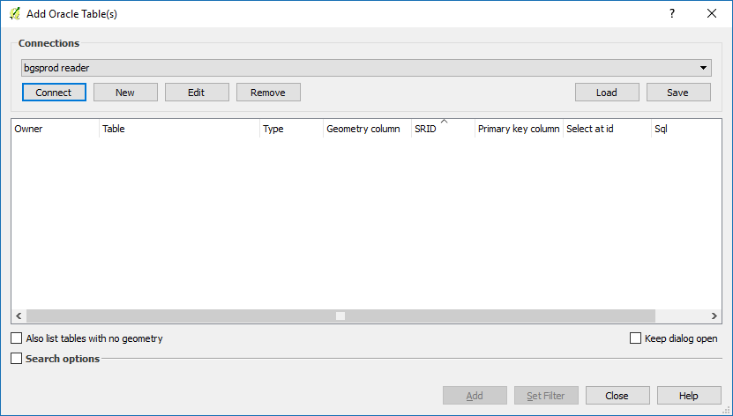

To load data from oracle, we first have to create a database connection. This tells QGIS which server and database to connect to and which user credentials it should use to log in.

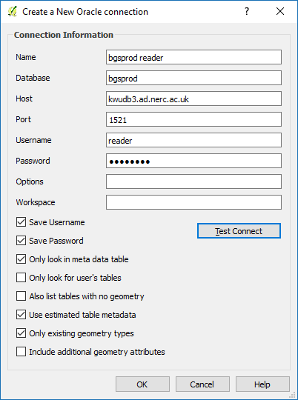

The “name” textbox allows us to enter a name for the connection so that we can have several different connections and be able to tell them apart. The other textboxes allow us to enter the connection parameters. In our case, we will connect to the BGS Production database to see the up to date onshore borehole data. We will log in using the username ‘Reader’ with the password ‘Choke693’.

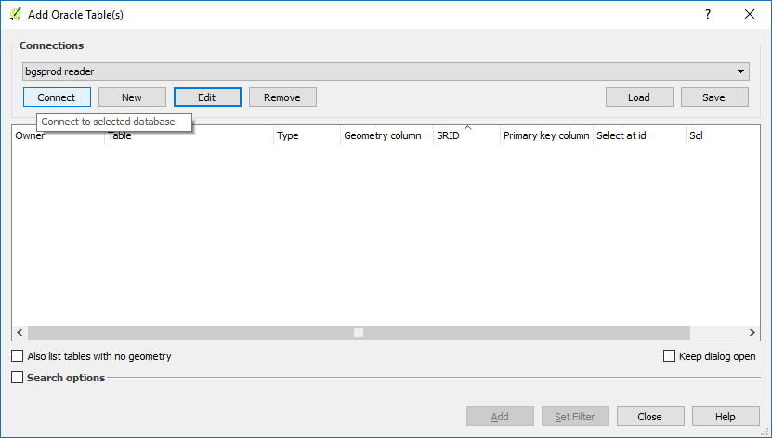

Once we have entered the connection parameters, we click on the Connect button to establish a connection. QGIS will take some time to enumerate the available tables; this can take up to several minutes, since BGS has so many tables.

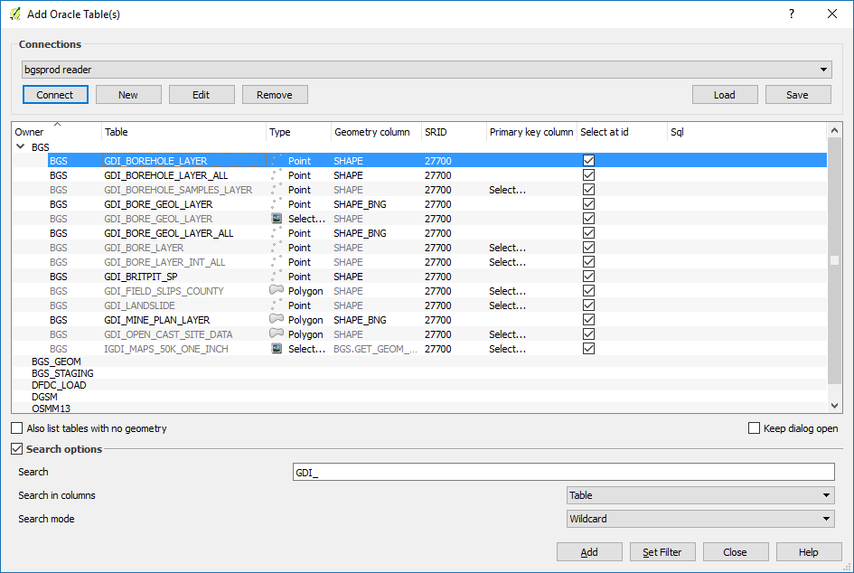

Navigate to the Owner ‘BGS’ and open the table ‘GDI_BOREHOLE_LAYER’. This table contains all onshore borehole information that is not confidential. You can filter the data (using SQL) so that only some records are loaded; this is done via the Set Filter button.

1. Core Plugins

Core Plugins are maintained by the QGIS Development Team and are automatically part of every QGIS distribution. Core plugins include:

* Coordinate Capture (Capture mouse coordinates in different CRSs)
* DB Manager (Exchange, edit and view layers and tables from/to databases; execute SQL queries)
* Dxf2Shp Converter (Convert DXF files to shapefiles)
* eVIS (Visualize events)
* GDALTools (Integrate GDAL Tools into QGIS)
* Georeferencer GDAL (Add projection information to rasters using GDAL)
* GPS Tools (Load and import GPS data)
* GRASS (Integrate GRASS GIS)
* Heatmap (Generate raster heatmaps from point data)
* Interpolation Plugin (Interpolate based on vertices of a vector layer)
* Metasearch Catalogue Client
* Offline Editing (Allow offline editing and synchronizing with databases)
* Oracle Spatial GeoRaster
* Processing (formerly SEXTANTE)
* Raster Terrain Analysis (Analyze raster-based terrain)
* Road Graph Plugin (Analyze a shortest-path network)
* Spatial Query Plugin
* Topology Checker (Find topological errors in vector layers)
* Zonal Statistics Plugin (Calculate count, sum, and mean of a raster for each polygon of a vector layer)

# References

British Geological Survey holds most of the references listed below, and copies may be obtained via the library service subject to copyright legislation (contact libuser@bgs.ac.uk for details). The library catalogue is available at: <https://envirolib.apps.nerc.ac.uk/olibcgi>.

Learning QGIS, 3rd Edition

User guide manual QGIS user guide 2.18 - http://www.qgis.org/en/docs/index.html